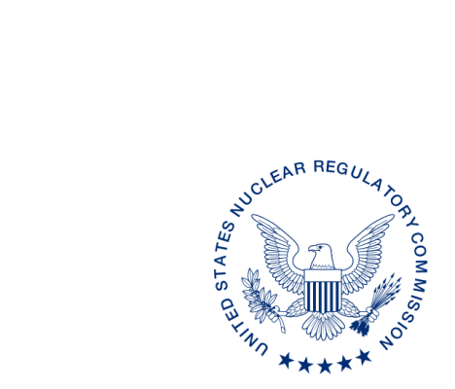
UNITED STATES
NUCLEAR REGULATORY COMMISSION
WASHINGTON, D.C. 20555-0001

{{date:long}}

[Name, Title]
[Address]

Dear [Name]:

We have reviewed the proposed revisions to the [State] regulations [State Regulation Sections], received by our office on [Date]. These regulations were reviewed by comparison to the equivalent U.S. Nuclear Regulatory Commission (NRC) rules and the requirements of Regulation Amendment Tracking System Identification Number[s] (RATS ID) [list RATS ID number(s)] as identified in the enclosed State Regulation Status (SRS) Data Sheet. We discussed our review of the regulations with [name of State person contacted] on [Date].

As a result of our review, we have [number] [comment/comments] that [has/have] been identified in the Enclosure 1. Please note that we have limited our review to regulations required for compatibility and/or health and safety. Under our current procedure, a finding that the [State] regulations meet the compatibility and health and safety categories of the equivalent NRC regulation may only be made based on a review of the final [State] regulations. However, we have determined that if your proposed regulations were adopted, incorporating our comment[s] and without other significant change, they would meet the compatibility and health and safety categories established in the Office of Nuclear Material Safety and Safeguards (NMSS) Procedure SA-200, “Compatibility Categories and Health and Safety Identification for NRC Regulations and Other Program Elements.”

We request that when the proposed regulations are adopted and published as final regulations, a copy of the “as published” regulations be provided to us for review. As requested in NMSS Procedure SA-201, “Review of State Regulatory Requirements,” please highlight the final changes and provide a copy to Division of Materials Safety, Security, State and Tribal Programs, NMSS.

The SRS Data Sheet in Enclosure 2 summarizes our knowledge of the status of other [State] regulations, as indicated. Please let us know if you note any inaccuracies or have any comments on the information contained in the SRS Data Sheet. This letter, including the SRS Data Sheet, is posted on: https://www.nrc.gov/agreement-states.
If you have any questions regarding the review, the compatibility and health and safety categories, or any of the NRC regulations used in the review, please contact my staff at AgreementStateRegs.Resource@nrc.gov.

Sincerely,

{{signature:ASG2}}

Adelaide S. Giantelli, Chief
State Agreement and Liaison Programs Branch
Division of Materials Safety, Security, State,
and Tribal Programs
Office of Nuclear Material Safety
and Safeguards

Enclosures:
- Compatibility Comment[s]
- [State] SRS Data Sheet
SUBJECT:

DISTRIBUTION: SP[05, 07 or 08]
DIR RF [Tracking number]
[Name], RSAO
TClark, NMSS

ADAMS Accession No. ML pkg and ML letter
OFFICE |  | NMSS/MSST | OGC | NMSS/MSST
NAME | [Reviewer] | [SRRC] |  | [Branch Chief]
DATE
OFFICIAL RECORD COPY

COMPATIBILITY COMMENT[S] ON [STATE] PROPOSED REGULATIONS

STATE SECTION |  | NRC SECTION | RATS ID | CATEGORY | SUBJECT and COMMENTS
0 | State or SSR citation | NRC citation | See State Regulation Status Sheet | Categories from SA-200  Compatibility  A, B, C,  NRC or H&S | [CFR TITLE]  Description of comment  Action State must take to meet compatibility.  Examples below
1 | N/A | 30.35(g), 40.36(f), 70.25(g) | 1996-3 | H&S | Financial assurance and recordkeeping for decommissioning  [State] has omitted requirements for the transfer of records pertaining to decommissioning in their regulations.  [State] needs to adopt the essential objectives of the requirements for the transfer of decommissioning records to the new licensee to meet the Category H&S designation assigned to 10 CFR 30.35(g), 40.36(f), and 70.25(g).
2 | [State citation] | 20.1003 | 2002-2 | A | Definitions  [State’s] proposed definition of “public dose” omits the phrase “does not include occupational dose” compared to NRC’s definition  [State] needs to add the phrase to [state citation] to meet the Compatibility Category A designation assigned to 10 CFR 20.1003.
3 | [State citation] | 20.1003 | 1999-3 | B | Definitions  [State’s] proposed definition of “fit test” omits the phrase “or quantitatively” compared to NRC’s definition. Fit tests should also have protocols to provide quantitative results.  [State] needs to add the above phrase to [state citation] to meet the Compatibility Category B designation assigned to 10 CFR 20.1003.
4 | [State citation] | 20.1401 | 1997-6 | C | General provisions and scope  [State] has omitted the requirements of paragraph (d). This requirement mandates that the peak annual TEDE be calculated for the first 1,000 years after termination of the license.  [State] needs to add paragraph (d) to [State citation] to meet the Compatibility Category C designation assigned to 10 CFR 20.1401.
5 | [State citation] | 37.43(d)(9) | 2013-1 | NRC | General security program requirements  10 CFR 37.43(d)(9) is a Compatibility Category NRC and should not be adopted by [State]. [State] needs to remove [citation] from their regulations.  [State] needs to make the above change in order to meet the Compatibility Category NRC designation assigned to 10 CFR 37.43(d)(9).

STATE REGULATION STATUS

