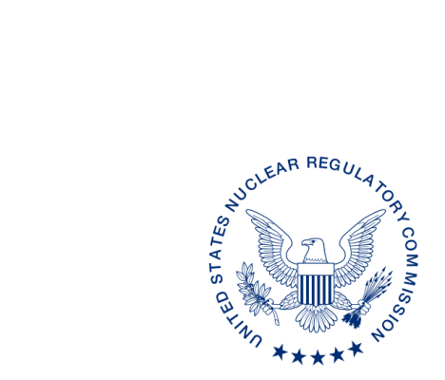
UNITED STATES
NUCLEAR REGULATORY COMMISSION
WASHINGTON, D.C. 20555-0001

{{date:long}}

[Name, Title]
[Address]

SUBJECT:

Dear [Name]:

We have reviewed the [State] legally binding requirement[s] [identify the legally binding condition description given by the State], received by our office on [Date]. [These/This] requirement[s] [were/was] reviewed by comparison to the equivalent U.S. Nuclear Regulatory Commission (NRC) rules and Regulation Amendment Tracking System Identification Number[s] (RATS ID) [list RATS ID number(s)] as identified in the enclosed State Regulation Status (SRS) Data Sheet. We discussed our review of the legally binding requirement[s] with [name of State person contacted] on [Date].

As a result of our review we have no comments. We have determined that the [State] legally binding requirement[s] meet[s] the compatibility and health and safety categories established in the Office of Nuclear Material Safety and Safeguards (NMSS) Procedure SA-200, “Compatibility Categories and Health and Safety Identification for NRC Regulations and Other Program Elements.”

The SRS Data Sheet summarizes our knowledge of the status of other [State] regulations, as indicated. Please let us know if you note any inaccuracies or have any comments on the information contained in the SRS Data Sheet. This letter, including the SRS Data Sheet, is posted on: https://www.nrc.gov/agreement-states.

If you have any questions regarding the review, the compatibility and health and safety categories, or any of the NRC regulations used in the review, please contact my staff at AgreementStateRegs.Resource@nrc.gov.

Sincerely,

{{signature:ASG2}}

Adelaide S. Giantelli, Chief
State Agreement and Liaison Programs Branch
Division of Materials Safety, Security, State,
and Tribal Programs
Office of Nuclear Material Safety
and Safeguards

Enclosure:
[State] SRS Data Sheet

SUBJECT:

DISTRIBUTION: SP[05, 07 or 08]
DIR RF [Tracking number]
[Name], RSAO
TClark, NMSS

ADAMS Accession No. ML pkg and ML letter
OFFICE |  | NMSS/MSST | OGC | NMSS/MSST
NAME | [Reviewer] | [SRRC] |  | [Branch Chief]
DATE
OFFICIAL RECORD COPY

STATE REGULATION STATUS

